
Lab Mid
Course: Information Security
Submitted to: Mam Ambreen
Submitted by: Attiqa
Reg no: Sp24-bse-050
Oct 21, 2025

Question 2 – Caesar Cipher (Decryption) [10 Marks]

Write a Python program to decrypt a message that was encrypted using the Caesar Cipher. The program should take ciphertext (LXFOPVEFRNHR) and key (5) as input and display the plaintext.
CODE:
ciphertext = input("Enter ciphertext: ")
shift = int(input("Enter shift: "))

plaintext = ""

for char in ciphertext:
if char.isalpha():
base = ord('A') if char.isupper() else ord('a')
plaintext += chr((ord(char) - base - shift) % 26 + base)
else:
plaintext += char

print("Plaintext:", plaintext)

OUTPUT:
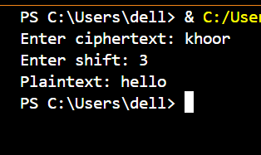

Question 3 – Vigenère Cipher (Decryption Only) [5 Marks]
Write a Python program to decrypt a ciphertext using the Vigenère Cipher. Ask the user for ciphertext and key, and display the decrypted plaintext
CODE:
ciphertext = input("Enter ciphertext: ").upper()
key = input("Enter key: ").upper()

plaintext = ""
key_index = 0

for char in ciphertext:
if char.isalpha():
shift = ord(key[key_index % len(key)]) - ord('A')
new_char = chr((ord(char) - ord('A') - shift) % 26 + ord('A'))
plaintext += new_char
key_index += 1
else:
plaintext += char

print("Plaintext:", plaintext)

OUTPUT:
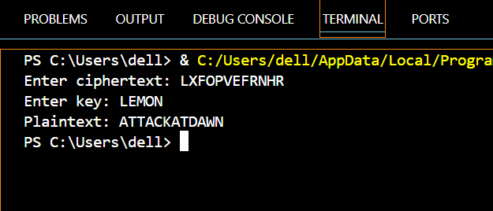

Question 4 – Debugging Task (Caesar Cipher Code) [5 Marks]
The following program is intended to encrypt text using the Caesar Cipher, but it contains an error. Fix the mistake so that it runs correctly and gives the right output
def caesar_encrypt(text, shift):
result = ""
for char in text:
if char.isalpha():
base = ord('A') if char.isupper() else ord('a')
result += chr((ord(char) - base + shift) % 26 + base)
else:
result += char
return result

msg = input("Enter message: ")
s = int(input("Enter shift: "))
print("Ciphertext:", caesar_encrypt(msg, s))

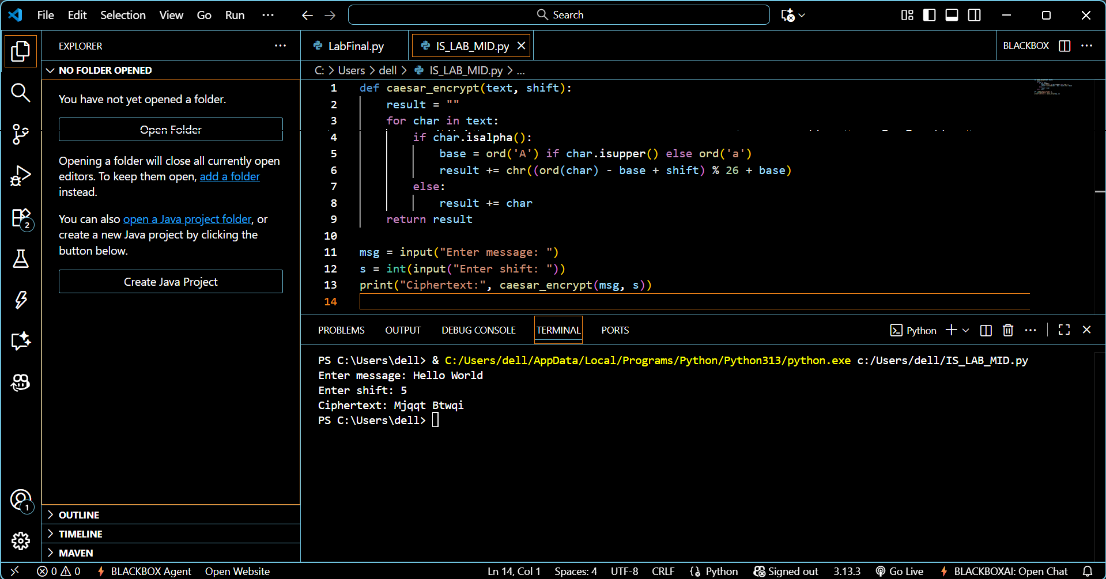

Question 5 – Conceptual: DES and AES [5 Marks]
Answer briefly:
a) Write one similarity between DES and AES. (2 marks)
Both DES and AES are symmetric key block ciphers, meaning the same secret key is used for both encryption and decryption.
b) What does CBC mode stand for in block ciphers? (2 marks)
CBC stands for Cipher Block Chaining. It links each plaintext block with the previous ciphertext block before encryption to make patterns less predictable.
c) Why is AES faster than DES? (1 mark)
AES is faster because it uses larger block sizes (128-bit) and more efficient operations than DES, which uses 64-bit blocks and older bit-level processing.

